Develop a VB Project to display the message using timer control

Form1 design:

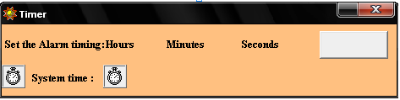

Form2 design:

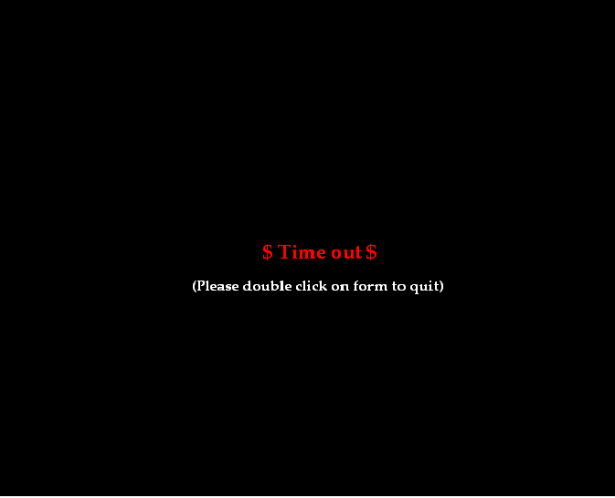

11.Display a message using Timercontrol

Aim:
To develop a VB Project to display the message using timer control

Coding:
Dim hh, mm, ss As Integer

Private Sub Command1_Click()

If (hh = 0 And mm = 0 And ss = 0 And Command1.Caption = "Stop") Then
End
End If

If (Command1.Caption = "Stop") Then
Timer1.Enabled = False
Command1.Caption = "Start"
Else
hh = Text1.Text
mm = Text2.Text
ss = Text3.Text
If (hh > 0 Or mm > 0 Or ss > 0) Then
Timer1.Enabled = True
Else
Timer1.Enabled = False
Form2.Enabled = True
End If
Command1.Caption = "Stop"
End If
End Sub

Private Sub Form_Load()
Command1.Caption = "Start"
Timer1.Enabled = False
Timer2.Enabled = True
Timer1.interval=1000
Timer2.interval=1000
hh = 0
mm = 0
ss = 0
End Sub

Private Sub Timer1_Timer()
If (ss > 0) Then
ss = ss - 1
Text3.Text = ss
If (hh = 0 And mm = 0 And ss = 0 And Command1.Caption = "Stop") Then
Timer1.Enabled = False
Form2.Enabled = True
Form2.Show
End If
Else
ss = 60
If (mm > 0) Then
mm = mm - 1
Text2.Text = mm
Else
mm = 59
If (hh > 0) Then
hh = hh - 1
Text2.Text = mm
Text1.Text = hh
End If
End If
End If
End Sub

Private Sub Timer2_Timer()
Label6.Caption = Format(Now, longtime)
End Sub

Form 2:
Private Sub Form_Click()
Form1.Show
Me.Hide
End Sub

Private Sub Label1_Click()
Form1.Show
Me.Hide
End Sub

Private Sub Label1 _DblClick()
Form1.Show
Me.Hide
End Sub

Output:

